# DAILY ONLINE ACTIVITIES SUMMARY

|  |  |  |  |  |  |  |  |
| --- | --- | --- | --- | --- | --- | --- | --- |
| **Date:** | **04/06/2020** | | | | **Name:** | **Sathvik R Shetty** | |
| **Sem & Sec** | **6th /B** | | | | **USN:** | **4AL17CS089** | |
| **Online Test Summary** | | | | | | | |
| **Subject** | | **OS IA Test - 3** | | | | | |
| **Max. Marks** | | **30** | | **Score** | | **17** | |
| **Certification Course Summary** | | | | | | | |
| **Course** | **Web Development** | | | | | | |
| **Certificate Provider** | | | **Shaw Academy** | **Duration** | | | **4weeks** |
| **Coding Challenges** | | | | | | | |
| **Problem Statement:**   1. Python program to print frequency of alphabets in a string in a specific format 2. Python program to combine strings. | | | | | | | |
| **Status: Completed** | | | | | | | |
| **Uploaded the report in GitHub** | | | | **Yes** | | | |
| **If yes Repository name** | | | | <https://github.com/sathvikshetty22/Online-Coding> | | | |
| **Uploaded the report in slack** | | | | **Yes** | | | |

**Online Test Details**

OS TEST-3 Details:

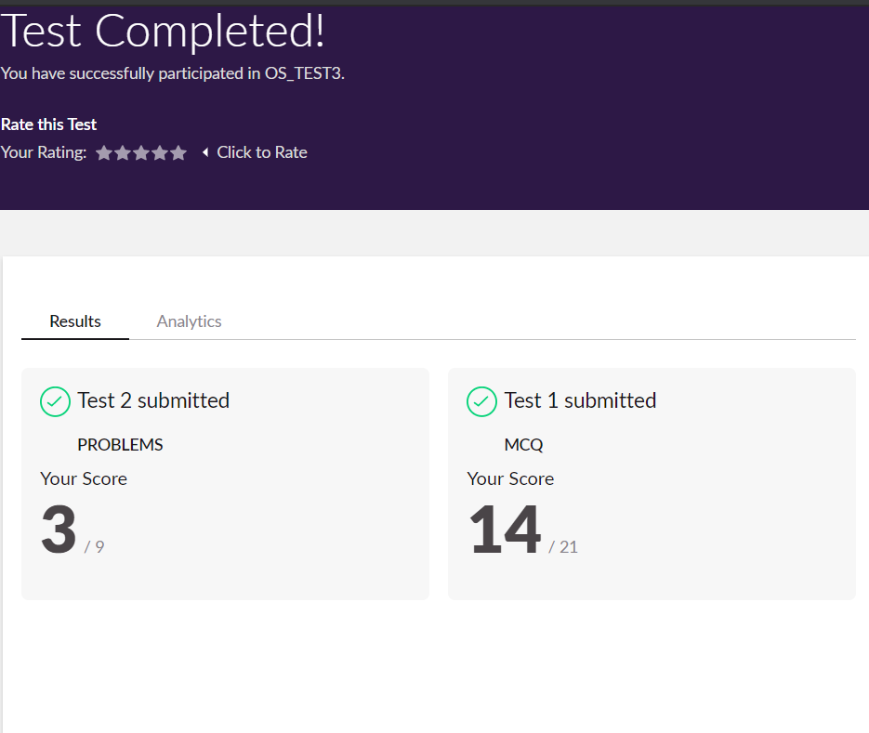

# Online Certification Details

**Lesson:**

* JavaScript fundamentals
* Setting up a web server

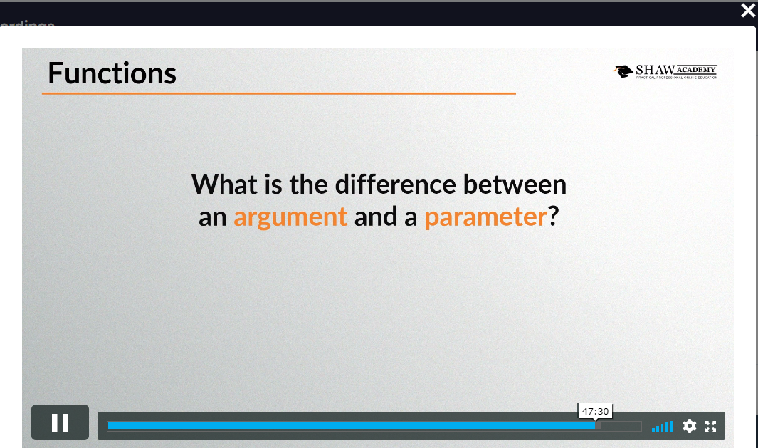

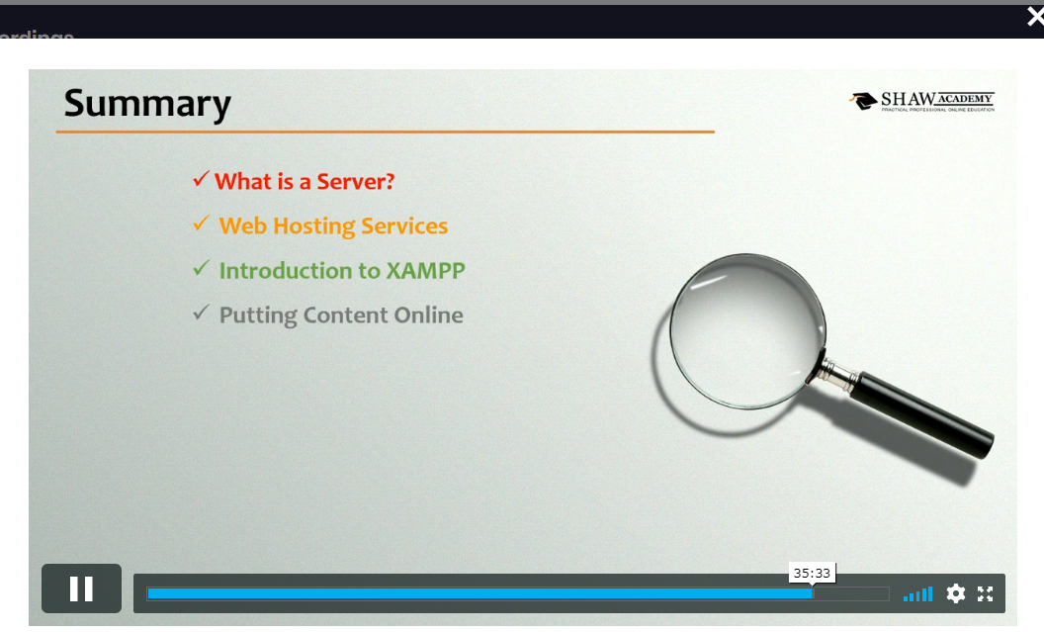

# Coding Challenge Details

1. Python program to print frequency of alphabets in a string in a specific format.

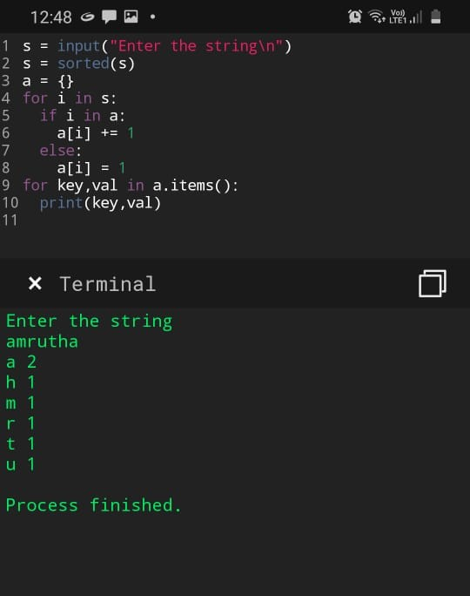

1. python program to combine string.

